**Assignment 3**

**Frozen Food Database Project**

**Due, Friday, February 12, 2021 for maximum 100%**

**Saturday, February 13, 2021 for maximum 90%**

**Sunday, February 14, 2021 for maximum 80%**

**Monday, February 15, 2021 for maximum 70%**

**Deliverables**

To complete this assignment, submit the following **three** files to Webcourses:

1. An SQL file (i.e. save the file with file extension .sql) containing the SQL written to perform the tasks.
2. An exported SQL file using MySQL Workbench Data Export option. The file name should be the following format: FirstnameLastnameAssignment#.sql. Example: KarinWhitingAssignment2.sql
3. An ER Diagram generated by MySQL Workbench. The file name should be the following format: FirstnameLastnameAssignment#ERDiagram.mwb. Example: KarinWhitingAssignment2ERDiagram.mwb

**Assignment Scope**

1. Use database **frozenfood**.
2. Create tables in the database.
3. Insert data into tables.
4. Generate an ER diagram.

**References**

1. 10_SQL Select Database.pptx
2. 11_SQL Create Table.pptx
3. 13_SQL Insert Query.pptx
4. 14_SQL Select Query.pptx
5. 15_SQL Where Clause.pptx
6. 16_SQL AND & OR Clauses.pptx
7. 25_AdvancedSQL Constraints.pptx
8. 26_AdvancedSQL Using Joins.pptx

**To access the DBMS**

1. Launch the MySQL Command Line Client executable or MySQL Workbench
2. Login in using the password set during installation “cgs2545” or your chosen password.

**Tasks**

|  |
| --- |
| Query Description |
| 1. Change to use the database frozenfood |
| 1. Create a table named product with the following attributes, data types, and constraints:    1. ID, integer, 7 characters, not null, auto increment    2. productName, variable character, 90 characters, not null    3. productType, variable character, 90 characters, not null    4. description, variable character, 90 characters, not null    5. size, variable character, 50 characters, not null    6. quantity, integer, 7 characters, not null    7. price, decimal, 7 characters, 2 to the right of the decimal point, not null    8. primary key is the ID field |
| 1. Create a table named employeeSupplier with the following attributes, data types, and constraints:    1. employeeId, integer, 7 characters, not null    2. supplierId, integer, 7 characters, not null    3. primary key is the employeeId and supplierId fields    4. foreign key on column employeeId references table employee column ID    5. foreign key on column supplierId references table supplier column ID |
| 1. Create a table named productSupplier with the following attributes, data types, and constraints:    1. productId, integer, 7 characters, not null    2. supplierId, integer, 7 characters, not null    3. primary key is the productId and supplierId fields    4. foreign key on column productId references table product column ID    5. foreign key on column supplierId references table supplier column ID |
| 1. Insert data in file product.sql into table product |
| 1. Insert data in file employeeSupplier.sql into table employeeSupplier |
| 1. Insert data in file productSupplier.sql into table productSupplier |
| 1. Generate an ER Diagram using MySQL Workbench, save as a .mwb file |
| 1. Export database frozenfood using MySQL Workbench, save as a .sql file |
| 1. Provide written source code in a .sql file |

|  |  |
| --- | --- |
| **Test Cases** |  |
| **Test Case 1** | Table **product** should look like Figure 1 |
| **Test Case 2** | Verify table **employeeSupplier** using the SQL command in file **testCase2TestCase3Code.sql**, result set should look like Figure 2 |
| **Test Case 3** | Verify table **productSupplier** using the SQL command in file **testCase2TestCase3Code.sql**, result set should look like Figure 3 |
| **Test Case 4** | ER Diagram should look like Figure 4 |

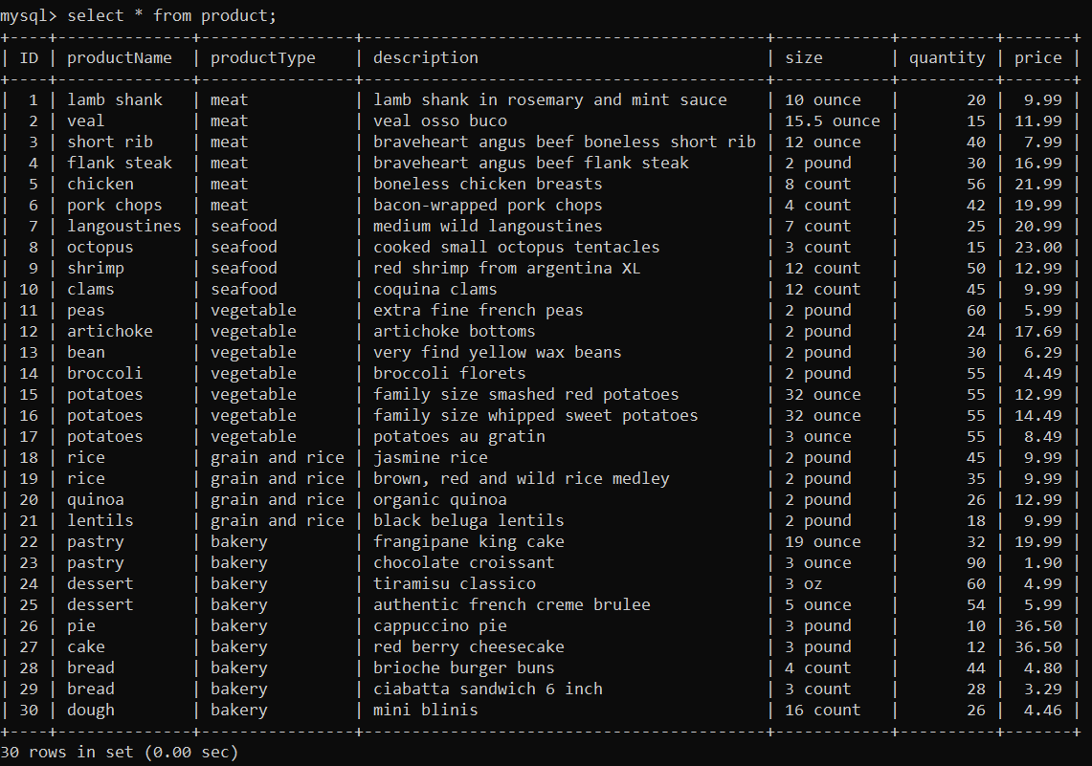

Figure 1 Table product

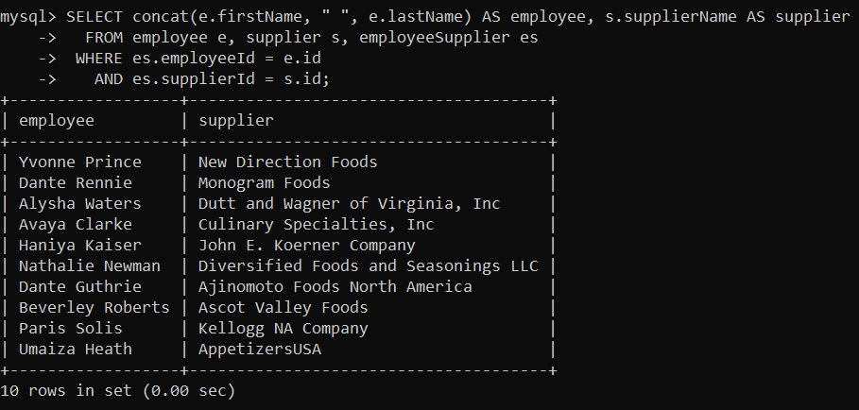

Figure 2 Table employeeSupplier

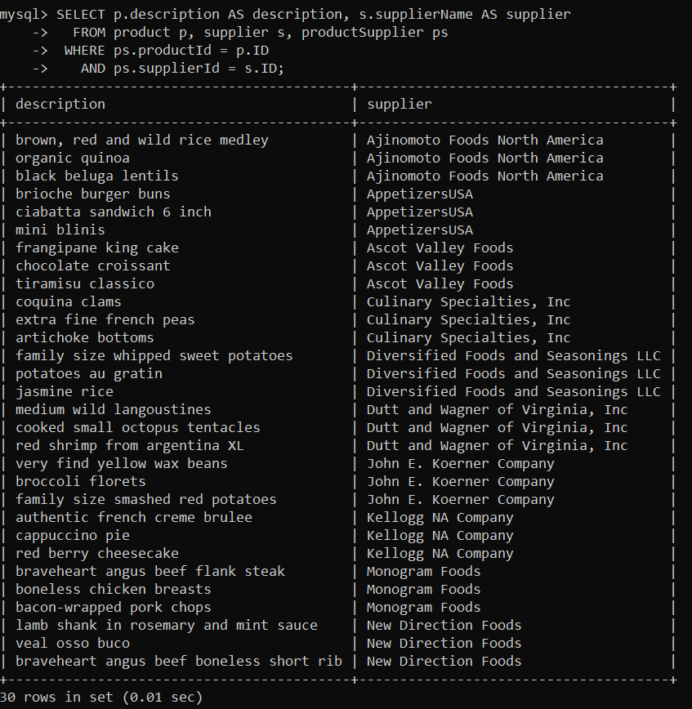

Figure 3 Table productSupplier

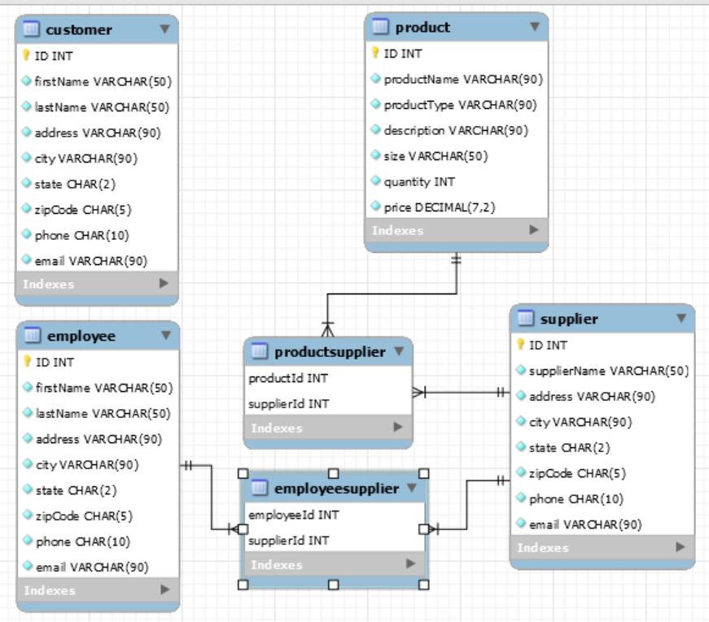

Figure 4 ER Diagram